# CS 255 System Design Document Template

This template lays out all the different sections that you need to complete for Project Two. Each section has guidance to prompt your thinking. You will need to continually reference the interview transcript as you work to make sure that you are addressing your client’s needs. There is no required length for the final document. Instead the goal is to complete each section based on what your client’s needs are. Remove this note when you are finished, and replace all bracketed text with the relevant information.

## UML Diagrams

### UML Use Case Diagram

*[In Module Six, you were asked to complete a use case diagram based on your system design. If you would like to make any adjustments to your diagram, please do so. Please insert your use case diagram here. Check to make sure that you included appropriate components and symbols and that your design meets the client’s needs.]*

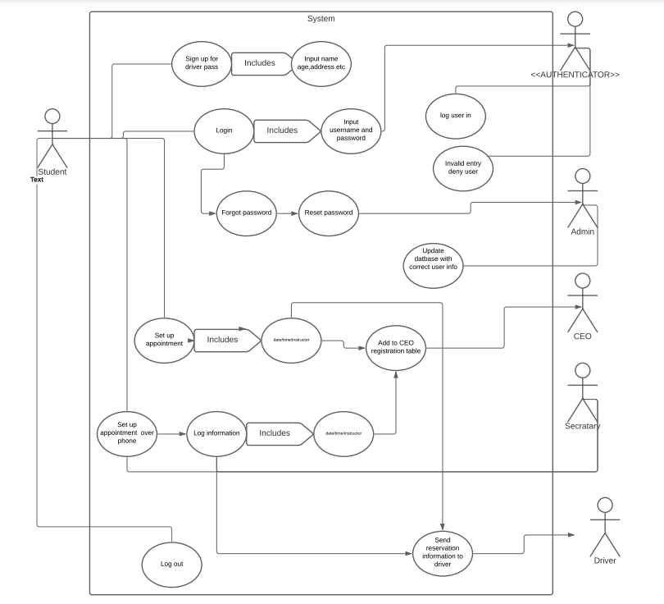

### UML Activity Diagrams

*[You were asked to choose* ***two*** *use cases and create* ***two*** *activity diagrams, one for each use case. Please insert* ***both*** *of your activity diagrams here. Check to make sure that you included appropriate components and symbols and that your design meets the client’s needs.*

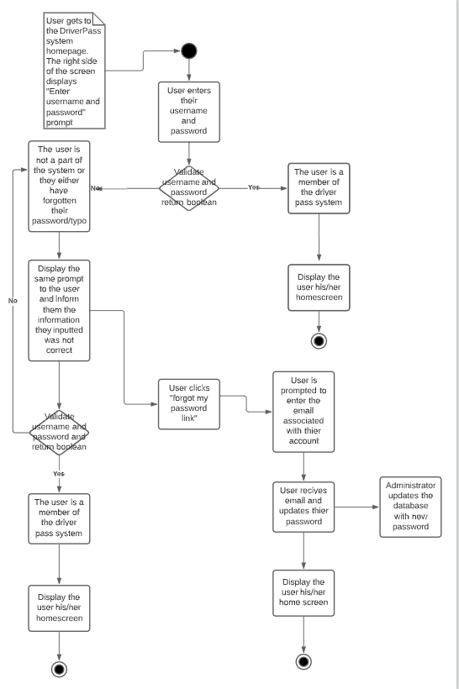

User log in

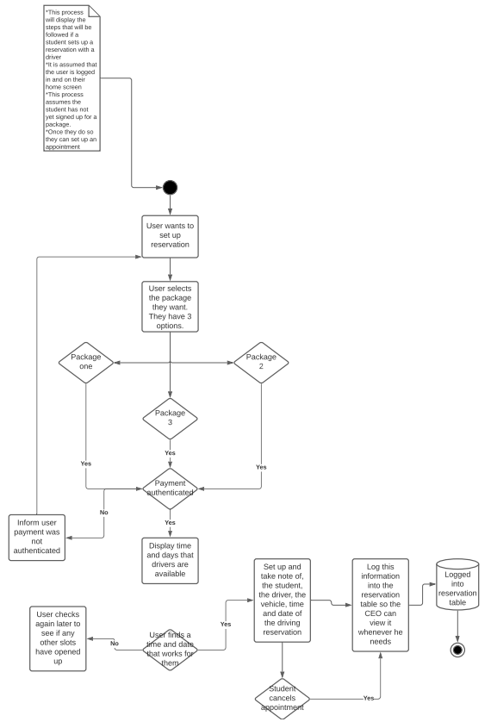

UML driving reservation

### UML Sequence Diagram

*[You were asked to create a sequence diagram based on* ***one*** *of the use cases you chose. Please insert your sequence diagram here. Check to make sure that you included appropriate components and symbols and that your design meets the client’s needs.]*

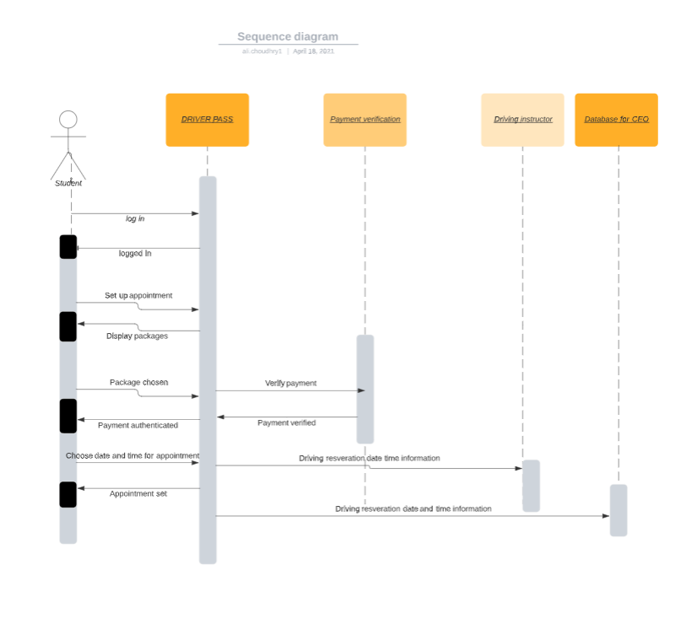

### UML Class Diagram

*[You were asked to create a class diagram based on the different classes and attributes needed for your system design. You are* ***not*** *required to include methods, but you may if you wish. Please insert your class*

*diagram here. Check to make sure that you included appropriate components and symbols and that your design meets the client’s requirements.]*

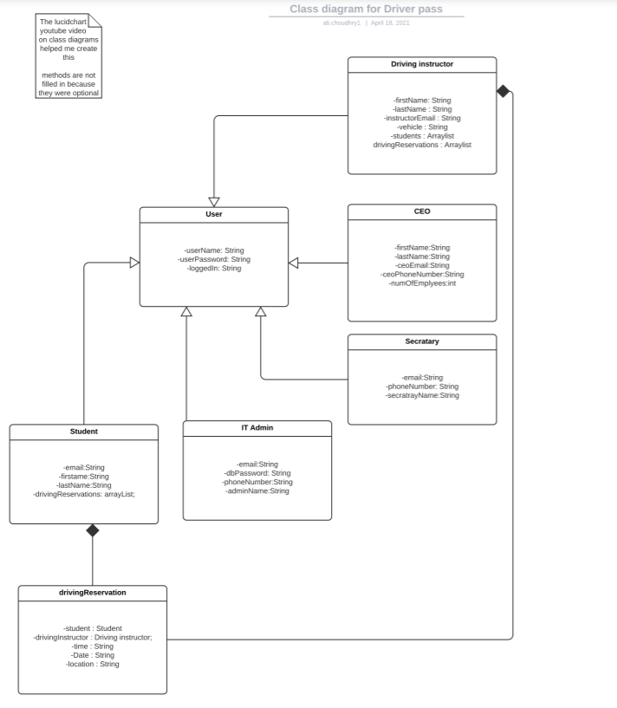

## Technical Requirements

*[Based on the diagrams you have created, describe the technical requirements of your system. These requirements should address the required hardware, software, tools, and infrastructure necessary for your system design.]*

* Since driver pass has chosen to use a cloud provider to handle their networking and hosting needs there will be no at home servers involved. This will make it easier for the driver pass company as they do not have to worry about setting up and maintaining these pieces of hardware.
* Using a cloud provider will also allow driver pass to scale up or down depending on their demand. If they have a massive influx of new users they can contact their cloud provider and request for more services.
* The software will be entirely web-based. A database will hold student account username as well as passwords. This will be needed when it is time to authenticate a user.
* The driver pass system will rely on a third party credit card verification system. This will be used when a student signs up for a driving package.
* The system shall allow the it administrator access to the database for when he/she has to reset a students account
* The system shall record all reservations and cancellations
* The system shall log in a user quickly, no longer than 5 seconds.